**CRM Application For Jewel Management**

**TEAM MEMBERS**

**ELAMATHI**

**GAYATHRI**

**LAKSHIMI PRIYA**

**RENUGA**

**Project Description:**

The Jewel Inventory System is a comprehensive software Solution designed to streamline and manage the inventory and sales processes of a jewellery store or a jewellery manufacturer. The system aims to provide an efficient and user-friendly solution to track and control the inventory of various jewellery items, maintain accurate records, and facilitate seamless sales transactions.

**System Requirements:**

1. Windows 8 machine
2. Install with two web browser
3. Bandwidth of 30mbps

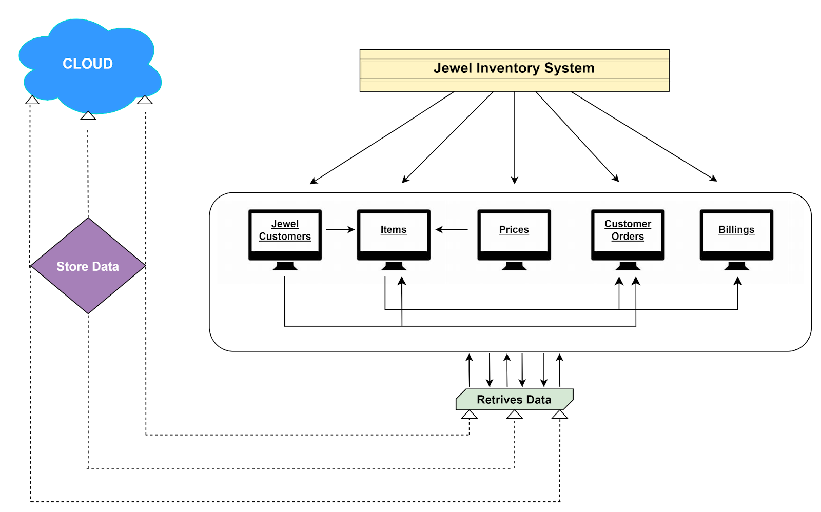

### OBJECT

### Create Jewel Customer Object

The purpose of creating a Jewel Customer custom object is to store and manage information about Customer.

To create an object:

1. From the setup page >> Click on Object Manager >> Click on Create >> Click on Custom Object.
2. Enter the label name >> Jewel Customer
3. Plural label name >> Jewel Customers

4.Enter Record Name Label and Format

* Record Name >> Customer name
* Data Type >> Text

Click on Allow reports.

Allow search >> **Save.**

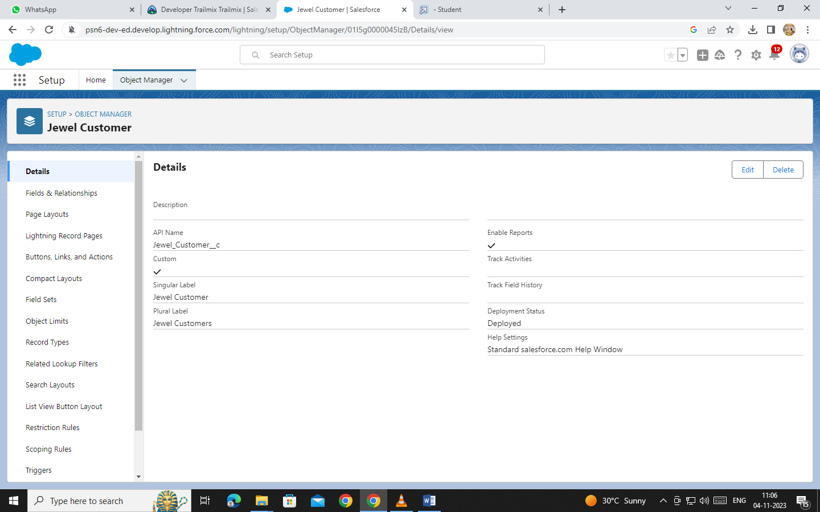

### Create Item Object

The purpose of creating a Item object is to manage the inventory of gold and silver items.

To create an object:

1. From the setup page >> Click on Object Manager >> Click on Create >> Click on Custom Object.
2. Enter the label name >> Item
3. Plural label name >> Items
4. Enter Record Name Label and Format

* Record Name >> Item Id
* Data Type >> Auto Number
* Display Format >> Item-{00}
* Starting Number >> 1

1. Click on Allow reports.
2. Allow search >> **Save**

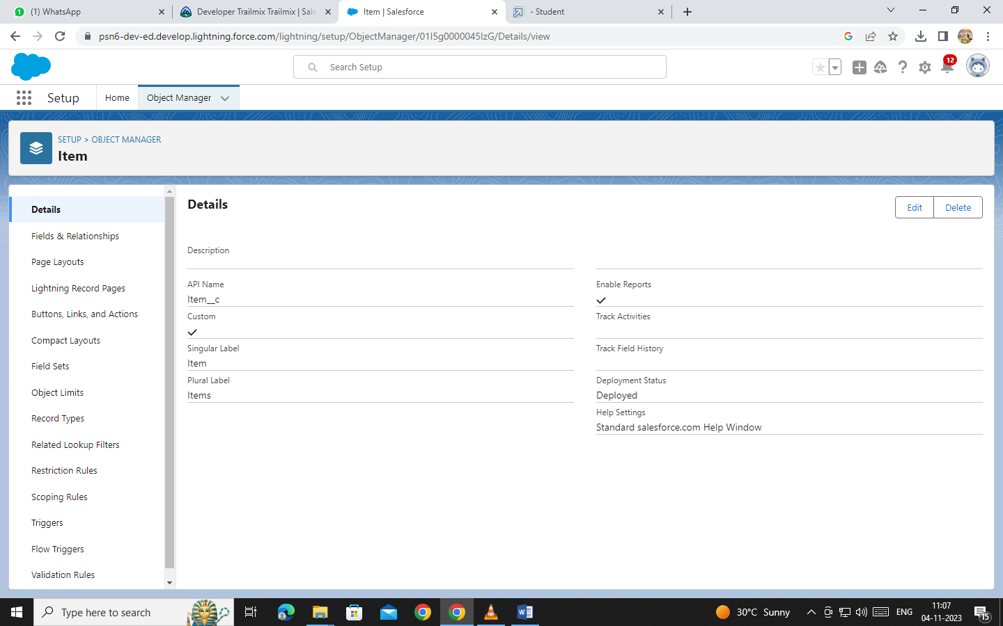

**TABS**

### Creating A Custom Tab

**To create a Tab:(Customer)**

1. Go to setup page ? type Tabs in Quick Find bar ? click on tabs ? New (under custom object tab)
2. Select Object(Jewel Customer) ? Select any tab style ? Next (Add to profiles page) keep it as default ? Next (Add to Custom App) keep it as default ? Save.

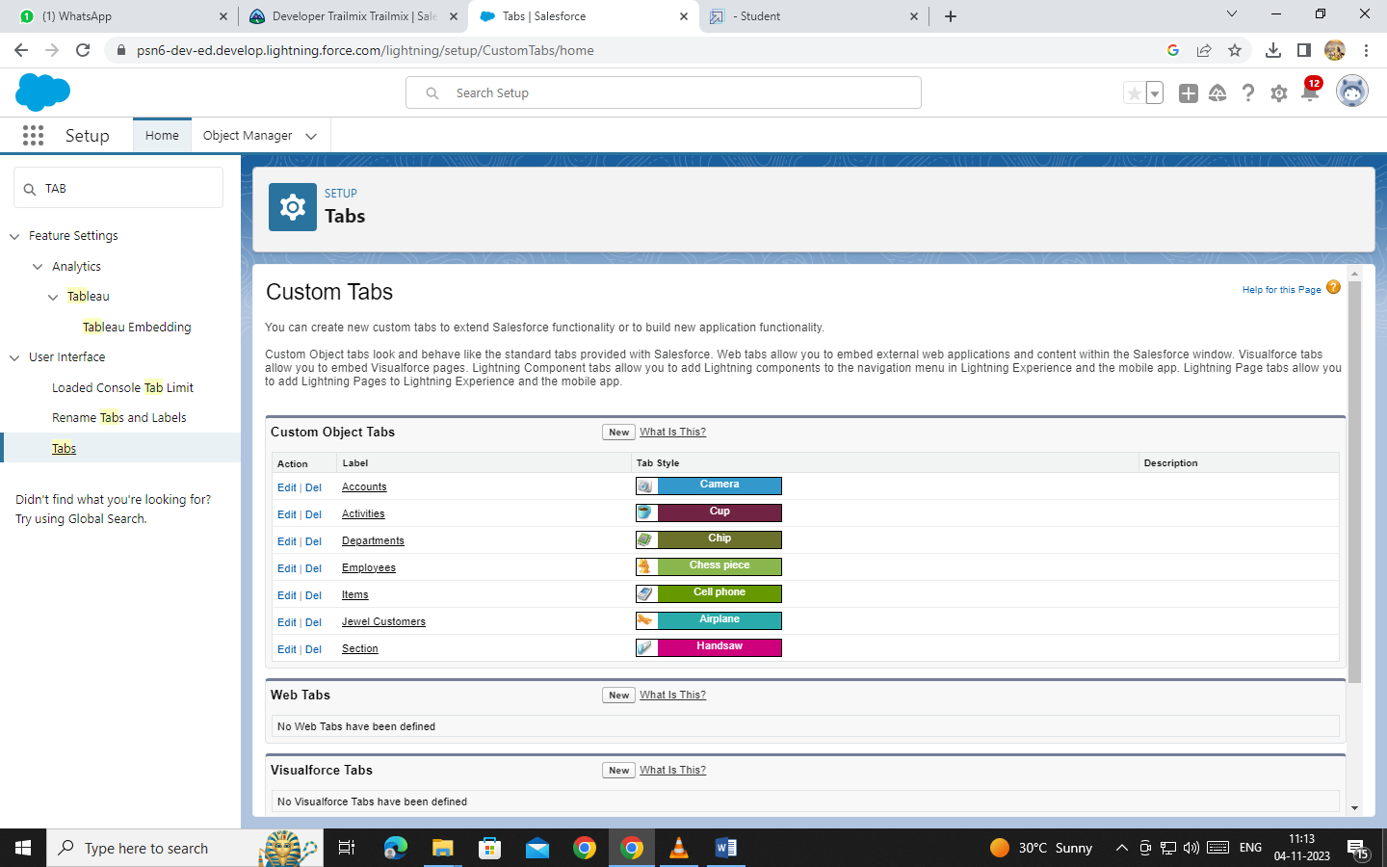

### LIGHTNING APP

### Create A Lightning App

**To create a lightning app page:**

1. Go to setup page >> search “app manager” in quick find >> select “app manager” >> click on New lightning App.
2. Fill the app name in app details and branding as follow  
   App Name : Jewellery Inventory System.  
   Developer Name : This will auto populated  
   Description : Elevate your look with elegance  
   Image : optional (if you want to give any image you can otherwise not mandatory)  
   Primary colour hex value : keep this default.
3. Then click Next  >> (App option page)Set Navigation Style as Console Navigation >> Next.
4. (Utility Items) keep it as default >> Next.
5. To Add Navigation Items:
6. To Add User Profiles:

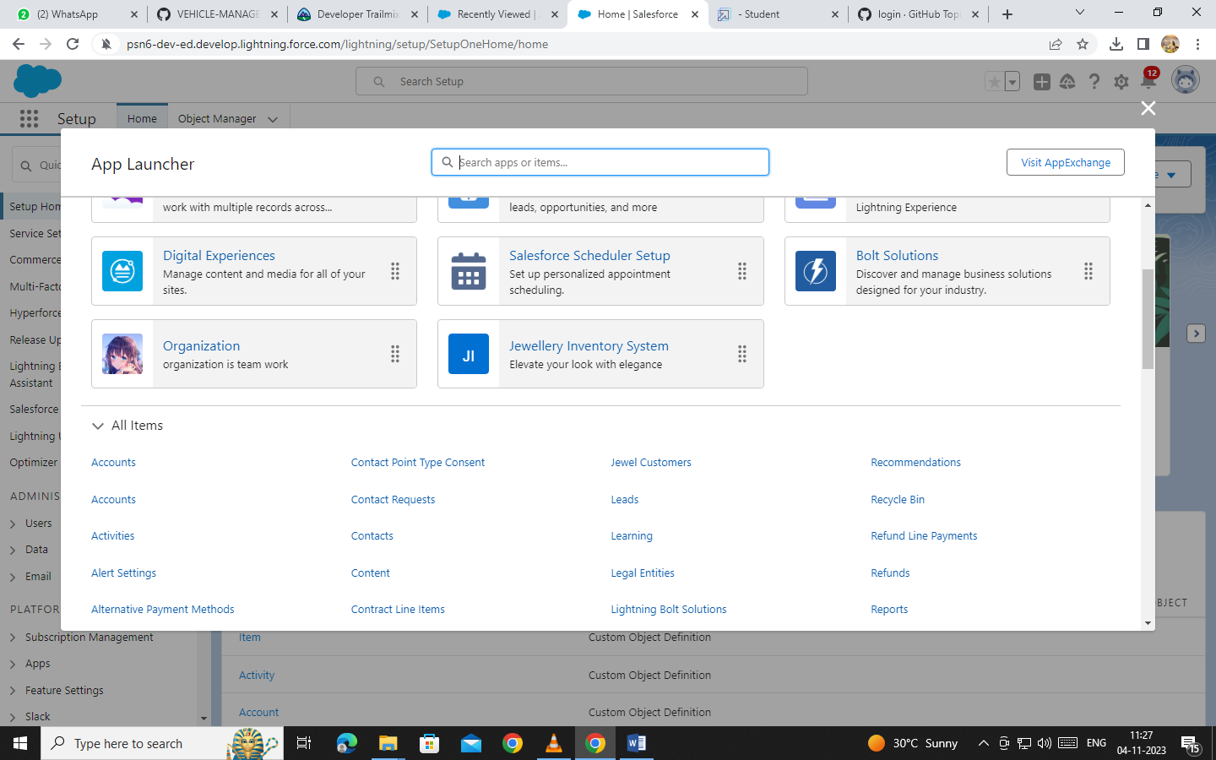

**FIELDS**

### Creating Lookup Relationship

## A Lookup relationship is a type of relationship in Salesforce that connects two objects together based on a field known as the Lookup field. It establishes a relationship between a child object and a parent object, allowing the child object to reference the parent object.

**To Create a relationship between Jewel Customer & Customer Order Objects.**

1. Go to the setup page >> click on object manager >>  type object name(Customer Order) in the quick find bar >> click on the object.
2. Click on fields & relationship >> click on New.
3. Select “Lookup relationship” as data type and click Next.
4. Select the related object “ Jewel Customer ”.
5. Give Field Label as “Customer” and click Next.
6. Next >> Next >> Save.

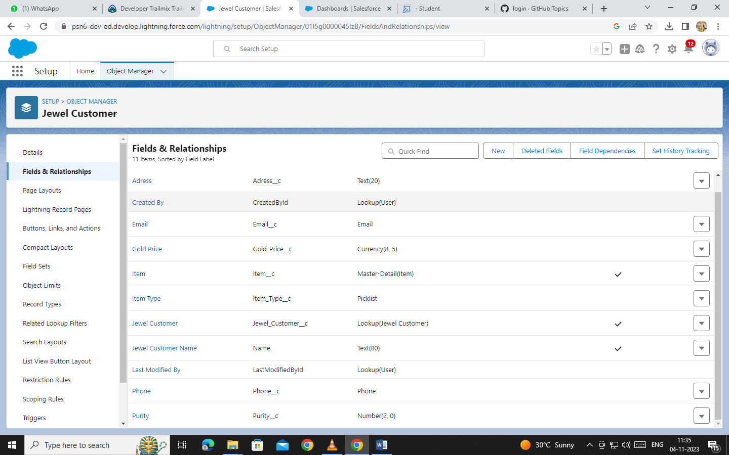

### Creating A Master-Detail Relationship

Master-detail relationship is a type of relationship between two objects where the master object controls certain behaviours and settings of the detail object. Here are a few use cases that demonstrate the use of master-detail relationships

**Creating Master-Detail Relationship between Item & Customer Order Object.**

To Create a Master-Detail relationship

1. Go to the setup page >> click on object manager >>  type object name(Customer Order) in the quick find bar >> click on the object.

2.Click on fields & relationships >> click on New.

3.Select “Master-Detail relationship” as data type and click Next.

4.Select the related object “ Item”.

5.Give Field Label as “Item” and click Next.

6.Next >> Next >> Save.

### Creating The Phone Field In Object Jewel Customer

To create fields in an object:

1. Go to setup >> click on Object Manager >> type object name(Jewel Customer) in quick find bar >> click on the object.
2. Now click on “Fields & Relationships” >> New
3. Select Data type as “Phone” and click Next.
4. Given the Field Label as “ Phone”.

### Creating The Email Field In Object Jewel Customer

To create fields in an object:

1. Go to setup >> click on Object Manager >> type object name(Jewel Customer) in quick find bar? click on the object.
2. Now click on “Fields & Relationships” >> New
3. Select Data type as “Email” and click Next.
4. Given the Field Label as “ Email”.

### Creating The Number Field In Item Object

To create fields in an object:

1. Go to setup >> click on Object Manager >> type object name(Item) in quick find bar >> click on the object.
2. Now click on “Fields & Relationships” >> New
3. Select Data type as “Number” and click Next.
4. Given the Field Label as “ Purity” and length as “ 2 ”.

### Creating Picklist Field In Item Object

To create fields in an object:

1. Go to setup >> click on Object Manager >> type object name(Item) in quick find bar >> click on the object.
2. Now click on “Fields & Relationships” >> New.
3. Select Data type as “Picklist” and click Next.
4. Enter Field Label as “Item Type”.
5. In values select “Enter values(Gold,Silver), with each value separated by a new line" and enter values as shown below.

### Creating Currency Field In Price Object

To create fields in an object:

1. Go to setup >> click on Object Manager >> type object name(Price) in quick find bar >> click on the object.
2. Now click on “Fields & Relationships” >> New.
3. Select Data type as “Currency” and click Next

### Creating Formula Field(Cross Object) In Item Object

To create fields in an object:

(Note:Create a Lookup Relationship in Item Object to Price Object with Field Name:Prices)

1. Go to setup >> click on Object Manager >> type object name(Item) in quick find bar >> click on the object.

1. Now click on “Fields & Relationships” >> New.
2. Select Data type as “Formula” and click Next.
3. Give Field Label and Field Name as “Gold Price” and select formula return type as “Currency” and click next.

**Creating The Validation Rule**

**Creating the validation rule for Postal Code field in Jewel Customer object**

**Note :** check whether the fields mentioned in the formula field are created or not , if not go to activity 10 and create those fields mentioned in Jewel Customer object.

1. Go to setup ? click on Object Manager ? type object name(Jewel Customer) in quick find bar? click on the object.
2. Click on the validation rule ? click New.
3. Enter the Rule name as “Postal Code “.
4. Insert the Error Condition Formula as : -

AND(

  OR(

    LEN( Zip_Postal_code__c ) <> 6,

    NOT(REGEX(Zip_Postal_code__c, "^[0-9]{6}$"))

  ),

  NOT(ISBLANK(Zip_Postal_code__c))

)

1. Enter the Error Message as “Must contain 6 digits”, select the Error location as Field and select the field as “Zip/Postal code”, and click Save.

**NOTE:**

**Create One more Validation rule for Jewel Customer object.**

1. Enter Rule name as “ValidationRule For JewelCustomerObject “.
2. Insert the Error Condition Formula as : -

    OR( ISBLANK( City__c ) , ISBLANK( Country__c ),ISBLANK( Phone__c ),ISBLANK( State__c ),ISBLANK(     Street__c ) )

1. Enter the Error Message as “Please fill Required fields”, select the Error location as Top of Page and click Save.

**Create Validation rule for Item object.**

1. Enter Rule name as “ValidationRule For Item“.
2. Insert the Error Condition Formula as : - OR( ISBLANK(  Amount__c  ) , ISBLANK(  Customer_Name__c  ) ,ISBLANK( Gold_price__c ),ISBLANK( KDM__c ),ISBLANK( Ornament__c ),ISBLANK( Percentage__c ),ISBLANK( Making_Charges__c ),ISBLANK( Prices__c ),ISBLANK( Stone_weight__c ),ISBLANK( Silver_price__c ),ISBLANK( Stone_other_price__c ),ISBLANK( Stone_weight__c ),ISBLANK( Weight__c ))
3. Enter the Error Message as “Please fill Required fields”, select the Error location as Top of Page and click Save.

**Create Validation rule for Billing object.**

1. Enter Rule name as “ValidationRuleForPaidAmount“.
2. Insert the Error Condition Formula as : -

                 (Paid_Amount__c > Total_Amount__c)

1. Enter the Error Message as “Paid amount cannot be greater than total amount”, select the Error location to field, select PayingAmount and click Save.

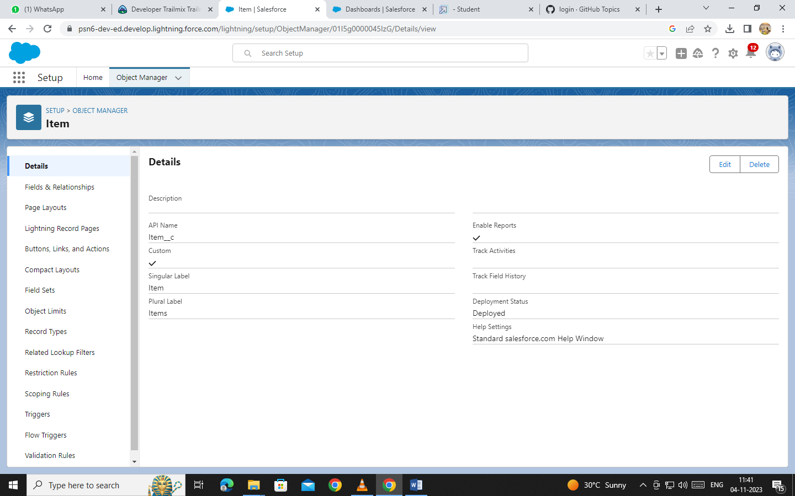

**PROFILE**

### Worker Profile

1. Go to setup ? type profiles in quick find box ? click on profiles ? clone the desired profile (Salesforce Platform User) ? enter profile name () ? Save.
2. While still on the profile page, then click Edit.
3. Scroll down to Custom Object Permissions and Give access permissions for Items,Price and Customer Order objects.
4. Scroll down and Click on Save.

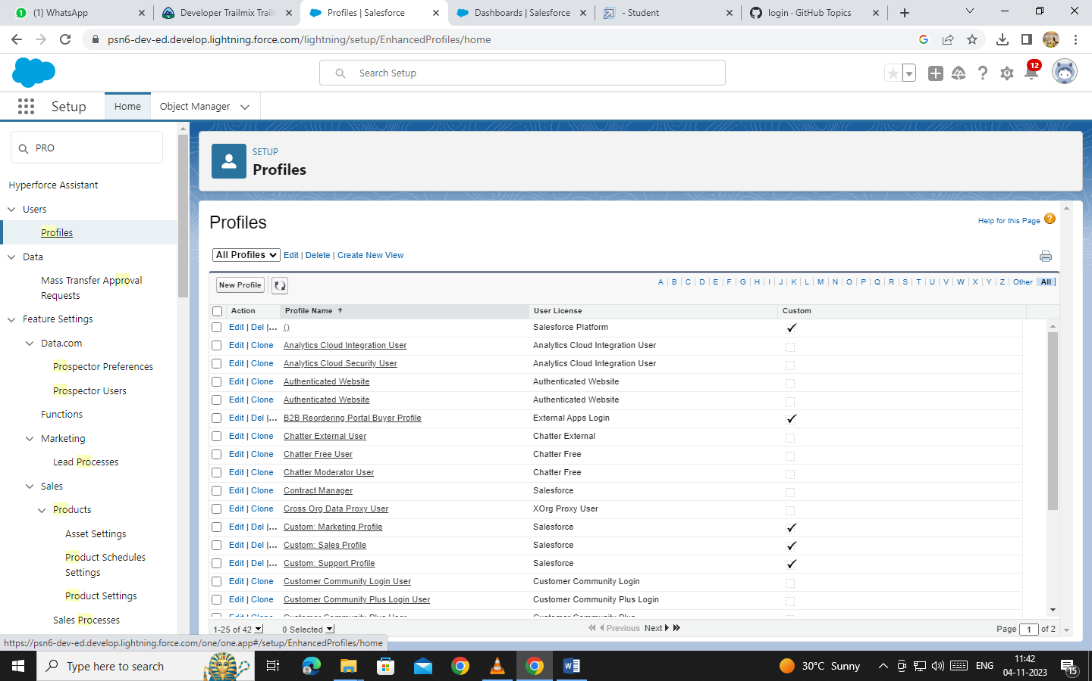

**ROLE**

A role in Salesforce defines a user's visibility access at the record level. Roles may be used to specify the types of access that people in your Salesforce organisation can have to data. Simply put, it describes what a user could see within the Salesforce organisation.

## **Use Case:**

You have successfully fulfilled the 1st requirement i.e., differentiating the users based on the functionality. Now comes the 2nd task of differentiating the users based on their position, using your excellent admin skills and expanding the custom roles for the organisation and assigning it to the users.

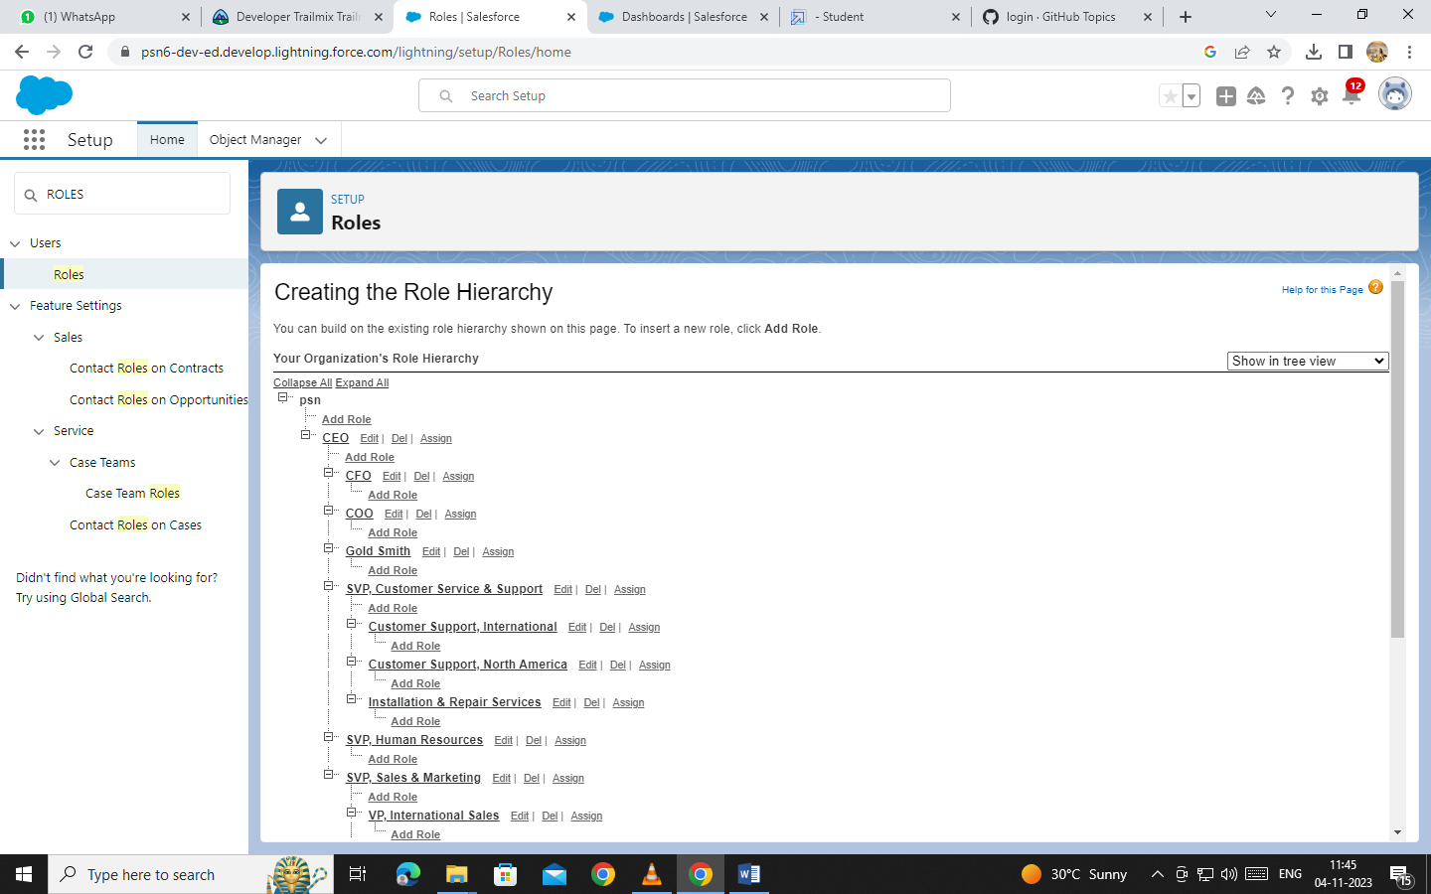

**USERS**

### Create User

1. Go to setup ? type users in quick find box ? select users ? click New user.
2. Fill in the fields
3. First Name : Niklaus
4. Last Name : Mikaelson
5. Alias : Give a Alias Name
6. Email id : Give your Personal Email id
7. Username : Username should be in this form: text@text.text
8. Nick Name : Give a Nickname
9. Role : Gold Smith
10. User licence : Salesforce
11. Profiles : Gold Smith

### Create User

1. Go to setup ? type users in quick find box ? select users ? click New user.
2. Fill in the fields

* First Name : Kol
* Last Name : Mikaelson
* Alias : Give a Alias Name
* Email id : Give your Personal Email id
* Username : Username should be in this form: text@text.text
* Nick Name : Give a Nickname
* Role : Worker
* User licence : Salesforce Platform
* Profiles : Worker

1. Save.

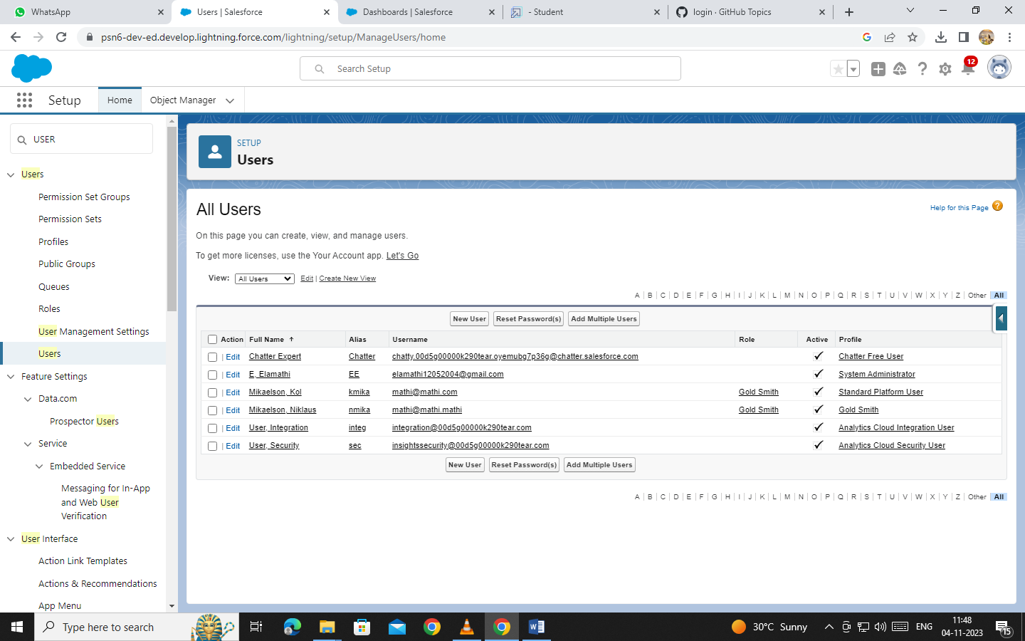

**PAGE LAYOUT**

### Page Layouts

Page Layout in Salesforce allows us to customise the design and organise detail and edit pages of records in Salesforce. Page layouts can be used to control the appearance of fields, related lists, and custom links on standard and custom objects' detail and edit pages.

## Use Case:

Hurray!! you have completed the data model structure for your organisation but while looking at the detailed and edit pages it seems to be so clumsy, so decide to organise the page in a pleasant way for the sake of good and pleasant appearance and assemble all different kinds of information in different sections in order.

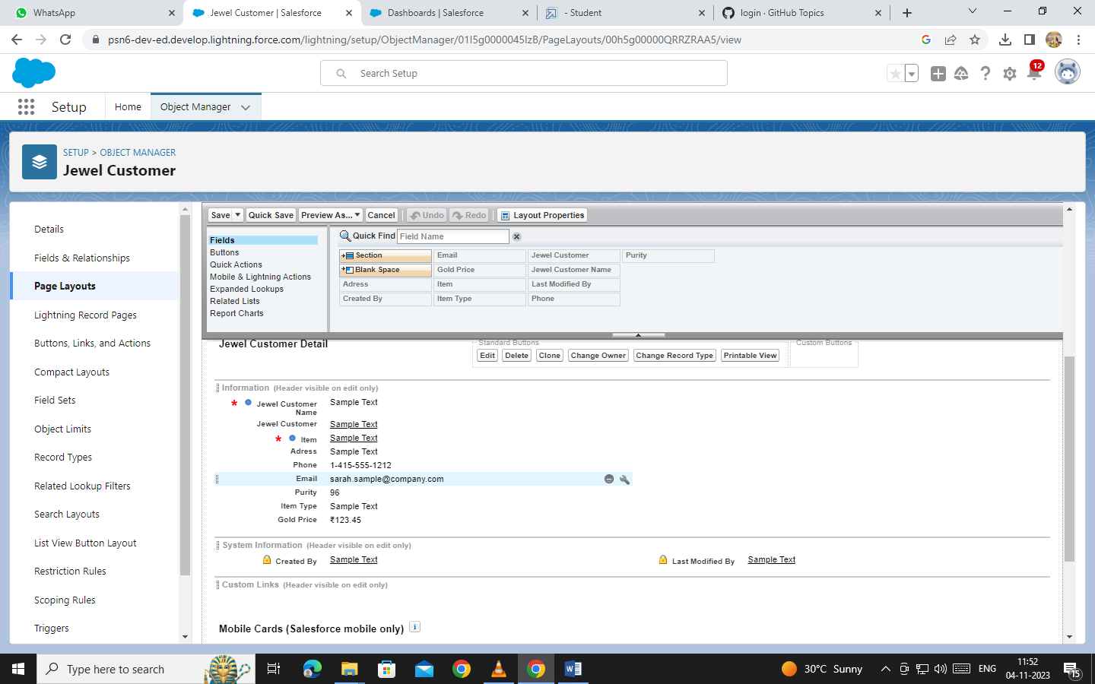

### Record Types

Record Types are a way of grouping many records of one type for that object. These can be applied to any standard or custom object, and allow you to have a different page layout, fields, required fields, and picklist values. Record types allow administrators to create a different page layout with custom picklist fields and values for the same business process and various business processes.

## Use Case:

All things done for the organisation. But some of the organisations feel it difficult to fill up all the details while creating a record, so GoldSmith assigned you a task to create different forms for Gold and Silver records based on their mode of work. As an Admin, you know how to achieve this.

### Trigger

# Use Case:

Trigger and Trigger handler is designed to handle scenarios where we used to update the "Paid Amount" field on a custom object called "Billing" based on the value in a field named "Paying Amount" during both record insertion and update operations. It Calculates and updates the "Paid Amount" field based on the existing "Paid Amount" and the new "Paying Amount" during record updates.This approach ensures that the "Paid Amount" accurately reflects the payments made by customers and provides a history of changes to the "Paid Amount" over time.

**Trigger** :

A trigger is a piece of Apex code that automatically runs before or after specific events, like record insertion, update, or deletion. Triggers are used to customise and automate actions in response to these events.

### Permission Sets

A standard permission set consists of a group of common permissions for a particular feature associated with a permission set licence. Using a standard permission set saves you time and facilitates administration because you don't need to create the custom permission set.

### User Adoption

## Use Case:

As a new Administrator, you perform user management tasks like creating and editing users, resetting passwords, granting permissions, configuring data access, and much more. In this unit, you will learn about users and how you add users to your Salesforce org.

### Reports

Reports give you access to your Salesforce data. You can examine your Salesforce data in almost infinite combinations, display it in easy-to-understand formats, and share the resulting insights with others. Before building, reading, and sharing reports, review these reporting basics.

Types of Reports in Salesforce

1. Tabular
2. Summary
3. Matrix
4. Joined Reports

**Use Case:**  
The GoldSmith of an organisation wants to have a brief data on Gold Items,Silver Items,Customer Orders and Billings. So he can have a clear picture of his organisation and be able to make any decisions required based on this data. So he calls you on this task and wants you to represent the data in an appropriate way.

Let’s create a Report.

### Dashboards

Dashboards help you visually understand changing business conditions so you can make decisions based on the real-time data you’ve gathered with reports. Use dashboards to help users identify trends, sort out quantities, and measure the impact of their activities. Before building, reading, and sharing dashboards, review these dashboard basics.

**Use Case:**

As an Admin for the organisation you keep pushing yourself to reach out the business requirements to take the organisation to peak heights and all your superiors are very much impressed with your efforts and work dedication. In addition with reports you make an ease for the GoldSmith in viewing the reports with data visualisation. So he doesn't have to search for the data he wants to check

### Flows

In Salesforce, a flow is a powerful tool that allows you to automate business processes, collect and update data, and guide users through a series of screens or steps. Flows are built using a visual interface and can be created without any coding knowledge.

**Use Case:**

Flows, also known as Salesforce Flows or Visual Flows, are powerful declarative automation tools in Salesforce that allow users to create and manage complex business processes without the need for code. Flows are designed using a drag-and-drop interface, making them easy to use for both administrators and developers. They can be used for various automation tasks like email triggers including data entry, record updates, and guided user interactions.

